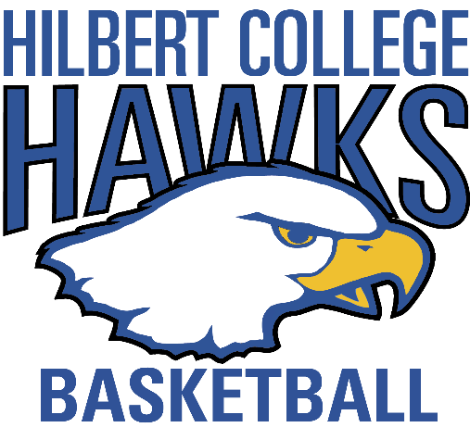
1st Annual Hawks Classic Registration:

Golfer Info:
Name: | Email: | Cell:

Others in your foursome:
Name: | Email: | Cell:
Name: | Email: | Cell:
Name: | Email: | Cell:

Top three preferred tee times (9:30am-2:00pm, 10 min intervals):
1.
2.
3.
Payment (Checks made out to “Hilbert College Men’s Basketball”) please check a box:
Mail to “Hilbert College Men’s Basketball” (Hafner Recreation Center: 5200 South Park Ave, Hamburg, NY 14075)

Drop off at the Men’s Basketball Office

Payment is required and registration is closed on 09/28. If you have any questions, please contact assistant men’s basketball coach – Matt Hartman at 716-913-9067 or hcmbbhawksclassic@gmail.com

